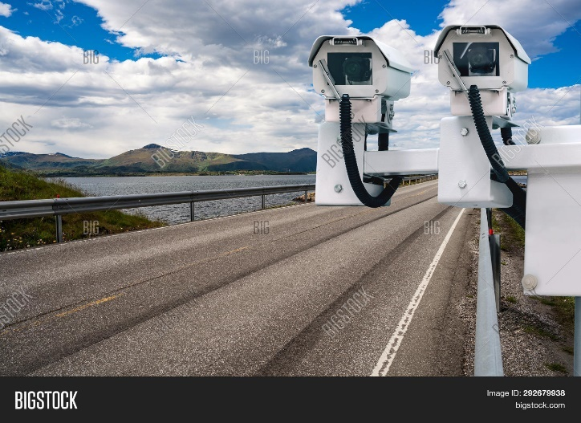

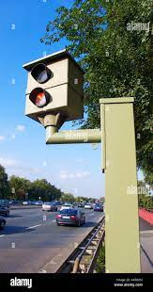

Street Radar and speed camera (comes in both shapes)

Siren alarm

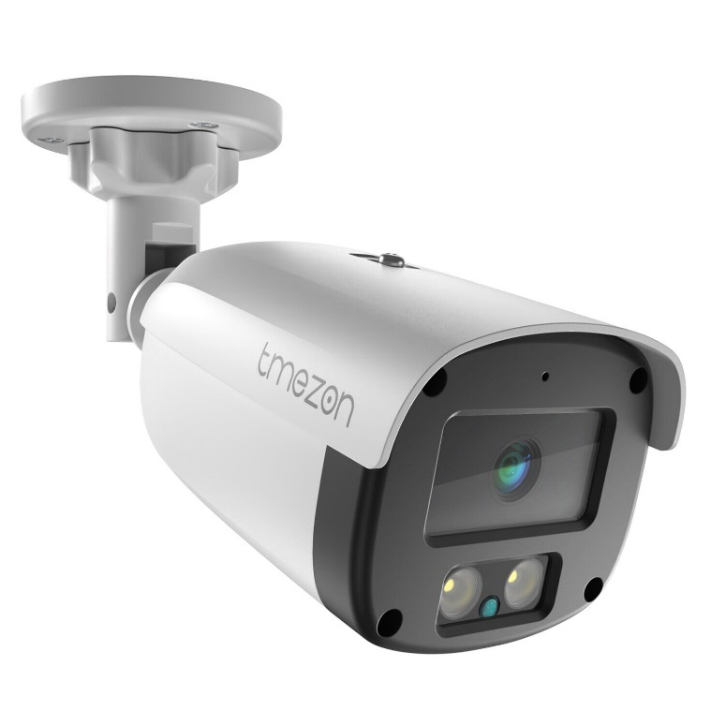

CCTV camera with night vision

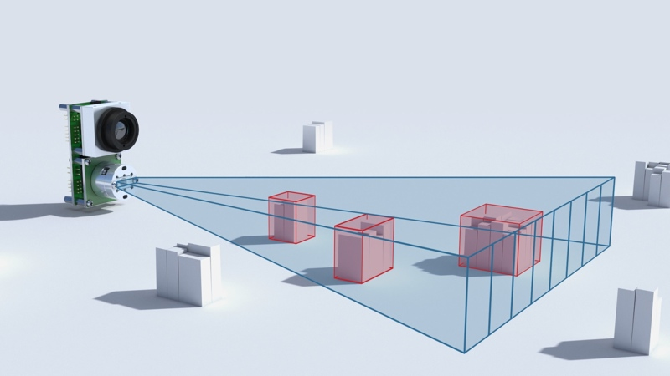

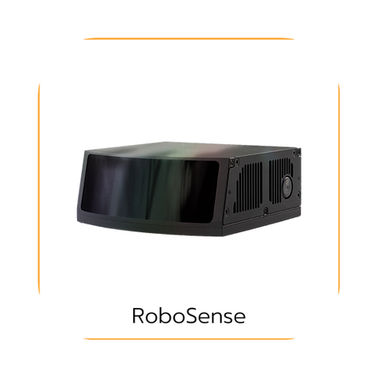

Solid State Lidar

RED LED

Model Components

Raspberry Pi camera module and camera multiplexer for using multiple cameras https://thepihut.com/products/multi-camera-doubleplexer-stereo-module-v2?variant=32124608315454&currency=GBP&utm_medium=product_sync&utm_source=google&utm_content=sag_organic&utm_campaign=sag_organic&gad_source=1&gclid=Cj0KCQiAn-2tBhDVARIsAGmStVmejMOemv7c2JQNycc-ZFTJnPSDUif6Clb9cqNQny52pBwDbjLvBCsaAvP9EALw_wcB

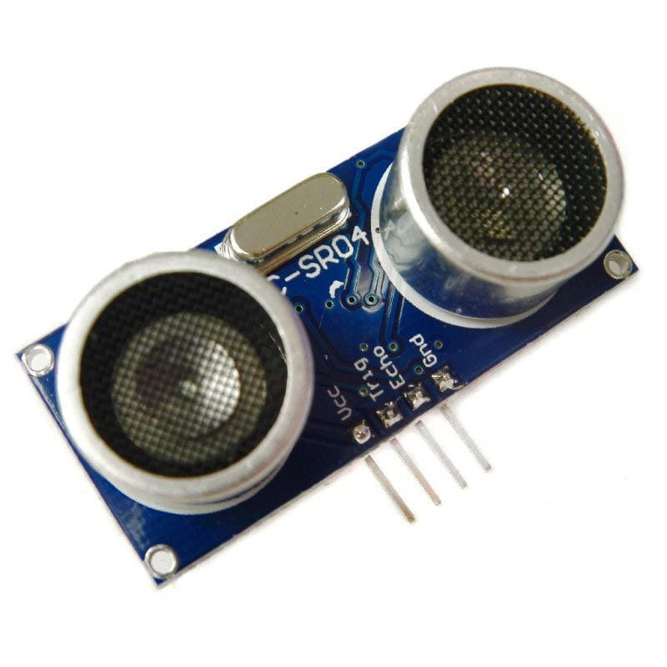

Ultrasonic Sensor (HC-SR04)

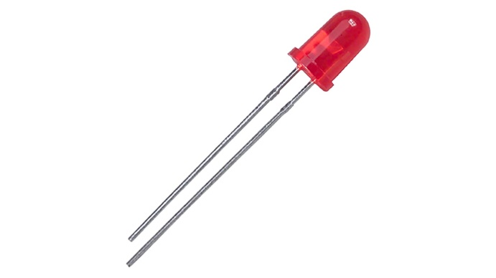

LED (red)

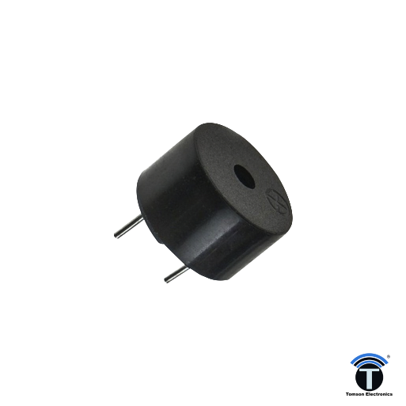

Buzzer

Solid state lidar does not exist for circuits, just large scale commercial applications.

Raspberry Pi pinout:

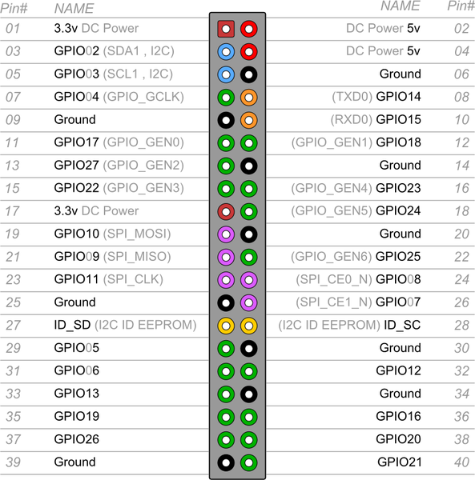

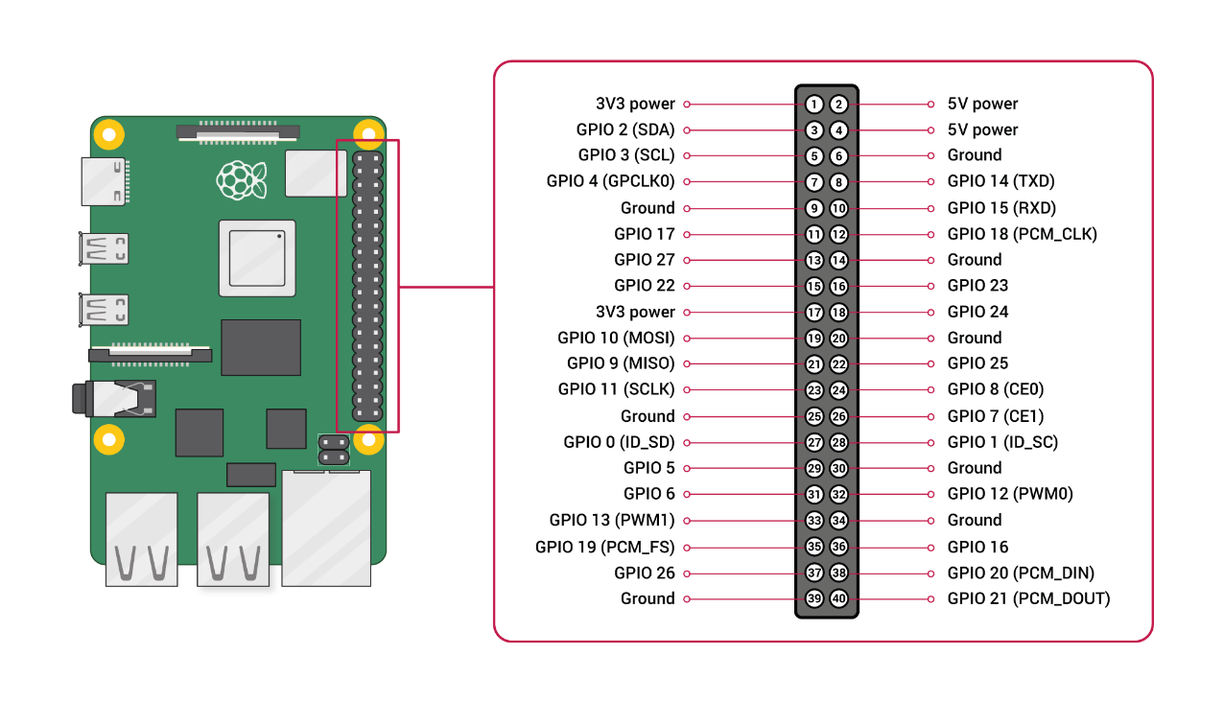

Might need RTC for the signal time

Trigger and echo go to GPIO

Camera connected via usb

pinout:

1. **3v3 Power:** This pin provides a 3.3V power supply. It can be used to power low-voltage components like sensors.
2. **5V Power:** This pin provides a 5V power supply. It can be used to power components that require 5V.
3. **GPIO 2 (SDA):** General Purpose Input/Output pin. SDA is commonly used as part of the I2C (Inter-Integrated Circuit) communication protocol.
4. **5V Power:** Another 5V power supply pin.
5. **GPIO 3 (SCL):** General Purpose Input/Output pin. SCL is commonly used as part of the I2C communication protocol.
6. **Ground:** This is the ground (0V) reference point for your circuits.
7. **GPIO 4 (GPCLK0):** General Purpose Input/Output pin. This can be used as a general-purpose digital input/output, or it has a special function related to clock generation.
8. **GPIO 14 (TXD):** General Purpose Input/Output pin. TXD is used for serial transmission (UART).
9. **Ground:** Another ground (0V) reference point.
10. **GPIO 15 (RXD):** General Purpose Input/Output pin. RXD is used for serial reception (UART).
11. **GPIO 17:** General Purpose Input/Output pin.
12. **GPIO 18 (PCM_CLK):** General Purpose Input/Output pin. This pin is related to Pulse Code Modulation (PCM) clock signals.
13. **GPIO 27:** General Purpose Input/Output pin.
14. **Ground:** Another ground (0V) reference point.
15. **GPIO 22:** General Purpose Input/Output pin.
16. **GPIO 23:** General Purpose Input/Output pin.
17. **3V3 Power:** Another 3.3V power supply pin.
18. **GPIO 24:** General Purpose Input/Output pin.
19. **GPIO 10 (MOSI):** General Purpose Input/Output pin. MOSI is used for SPI (Serial Peripheral Interface) communication.
20. **Ground:** Another ground (0V) reference point.
21. **GPIO 9 (MISO):** General Purpose Input/Output pin. MISO is used for SPI communication.
22. **GPIO 25:** General Purpose Input/Output pin.
23. **GPIO 11 (SCLK):** General Purpose Input/Output pin. SCLK is used for SPI communication.
24. **GPIO 8 (CE0):** General Purpose Input/Output pin. CE0 is used for SPI communication as a chip select.
25. **Ground:** Another ground (0V) reference point.
26. **GPIO 7 (CE1):** General Purpose Input/Output pin. CE1 is used for SPI communication as a chip select.
27. **GPIO 0 (ID_SD):** ID_SD and ID_SC are reserved for I2C use when connecting multiple Raspberry Pis.
28. **GPIO 1 (ID_SC):** Reserved for I2C use.
29. **GPIO 5:** General Purpose Input/Output pin.
30. **Ground:** Another ground (0V) reference point.
31. **GPIO 6:** General Purpose Input/Output pin.
32. **GPIO 12 (PWM0):** General Purpose Input/Output pin. PWM0 is used for pulse-width modulation.
33. **GPIO 13 (PWM1):** General Purpose Input/Output pin. PWM1 is used for pulse-width modulation.
34. **Ground:** Another ground (0V) reference point.
35. **GPIO 19 (PCM_FS):** General Purpose Input/Output pin. PCM_FS is related to Pulse Code Modulation (PCM).
36. **GPIO 16:** General Purpose Input/Output pin.
37. **GPIO 26:** General Purpose Input/Output pin.
38. **GPIO 20 (PCM_DIN):** General Purpose Input/Output pin. PCM_DIN is related to Pulse Code Modulation (PCM).
39. **Ground:** Another ground (0V) reference point.
40. **GPIO 21 (PCM_DOUT):** General Purpose Input/Output pin. PCM_DOUT is related to Pulse Code Modulation (PCM).

Schematic for model (multiplexer available or we will be using a usb port webcam and no need for rtc)

* 1. Installed KiCad
  2. Created a new schematic
  3. Imported Raspberry Pi symbol from the symbol library to the schematic
  4. Imported red and green LEDs from the symbol library for both traffic pole and pedestrian pole
  5. Imported yellow LED from the symbol library for traffic pole.
  6. LEDs need 330Ω resistors
  7. Imported the Ultrasonic sensor HC-SR04 component
  8. Imported additional 2 resistors with values 330 Ω and 470 Ω resistances for the connection to the echo pin ion the HC-SR04
  9. Imported the buzzer to the schematic
  10. Imported a push button switch for the pedestrian pole
  11. Imported a resistor with value of 270 Ω for the switch
  12. Connected the components to the raspberry pi and the connections were as follows:

Resources for schematic:

<https://www.google.com/url?sa=i&url=https%3A%2F%2Fwww.makerspace-uk.co.uk%2Fdc-buzzers%2F&psig=AOvVaw2Ye4E9W7SQoaoEQ1krBKPT&ust=1707148688662000&source=images&cd=vfe&opi=89978449&ved=0CBUQjhxqFwoTCMiL2sqGkoQDFQAAAAAdAAAAABAh>